UFEC General Body Meeting Minutes-March 13, 2013

President: Joanna Reeg
- Welcome!
- Keep on top of Active Member Requirements!!
- Rec Sports Banquet- $10
- April 24th
- Elections

Vice-President: Micah Murphy
- Women’s Lacrosse Friday, 3/16 @ 4pm SW Fields
- Men’s Soccer Friday evening, 3/22- more info to come
- Jungle Friends Primate Sanctuary
- 3/30 @ 9:30pm-2pm
- Only 10 slots! First come, first serve!
- Donate supplies for Helping Hands Pet Rescue
- See email sent through listserv after meeting for specifics!!!- Bring by next meeting
- Project Foster Kids Play Day for Florida Bible Camp
- 4/13 @ 12-4pm (lunch provided)
- Dr. Tembrooke Community Service Opportunity:
- Horse Tales Literacy Project
- Volunteers needed 9 a.m.- 12:45 p.m. April 25th & 26th at the HTU
- Call for Volunteers: May 9th at Canterbury

Treasurer: Carmen Dolling
- We have a lot of money!
- Talk to Carmen if you’re running for Treasurer!

Secretary: Hayden Manuel
- Sign in
- Keep up with Active Member Requirements
- Email me with excuses.
- Talk to me if you’d like to be secretary!

Public Relations: Kim Schell
- BANQUET!
- April 3rd
- Final time TBA (6-9)- Most likely across the street at the vet school
- Sign-ups
- $5 per person
- Please send in pictures from the year for Slideshow!
- Limit 5 per person

Fundraising: Elle Keenan
- Tijuana Flats
- Archer location
- Monday 3/18
- 6-8pm
- Next fundraiser- Sweet Dreams!
- Need flyers for Tijuana Flats- Elle will send them out and out them on Facebook!

Socials- Keri Allen
- Rugby Party- March 23rd! Time TBA
- If you attended .08 sec put your name on the list!

Merchandise: Leah Feiner
- Orders are in! Pick up from the officers after the meeting!
- We sold over 25 fan shirts at last weekend’s IEA Regionals show at Kimberden! Only larges and XL left, $15
- Talk to Leah if running for merch chair!
- Sign up for your team shirt this meeting. There will be no extras so be sure to preorder! Please only sign up if you will commit to bringing payment to the next meeting/to Leah

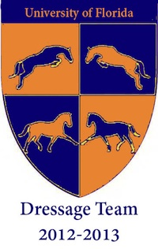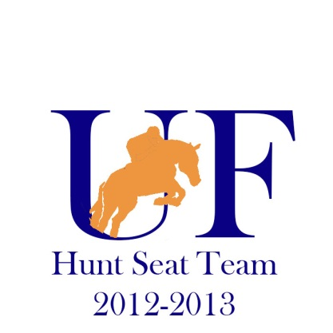
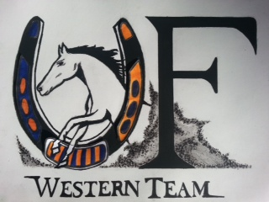

Dressage Team: Kelsey Harrell
- New Co-Captain: Alexa Roth
- 860-753-1340
- alexa.roth@ufl.edu
- New Show Date!
- April 6th & 7th
- Signups being passed around
- Makeups will be 3/23 and 4/5
- Mandatory Practice Show for Team
- 3/16 @ Hallet Training
- Wear tall boots, breeches, and a polo
- Be there between 8-9 a.m.

Hunt Seat Team: Lindsey Powers & Sam Boehm
- Reimbursements from Sam
- Intramural is cancelled
- Regionals Recap- Congrats Keri & Taylor!!
- Zones (4/6) Info

Western Team: Brooke Adkins & Marvin Davila
- Team dinner at the Melting Pot! No more than $15, must have shown at least once
- Sam is still doing lessons!
- Buy shirts from Brooke….
- FSU Reimbursements

Nominations:
President: Hayden Manuel, Elle Keenan
Vice President: Kim Schell
Secretary: Mallory Nebel
Treasurer: Katie Pascale, Mallory Nebel, Meaghan O’Neil
Merchandise Chair: Natasha Phillips, Meaghan O’Neil, Stephanie Trappberger
Social Chair: Leah Harmon
Public Relations: Rachel Herman
Fundraising Chair: Jacklyn Locklear, Rachel Herman, Kiersten Allison
Hunt Seat Captain: Emily Rizzo, Sam Boehm, Alex Danovitch
Hunt Seat Co-captain: Ali Unger-Fink, Kendall Jones, Sam Kennedy, Natasha Phillips
Western Captain: Joanna Reeg, Ashley Coxen
Western Co-captain: Joanna Reeg, Brie Bird
Dressage Captain: Kelsey Harrell
Dressage Co-captain: Alexa Roth

Next Meeting
Wednesday
March 20th, 2013
@ ANS156

